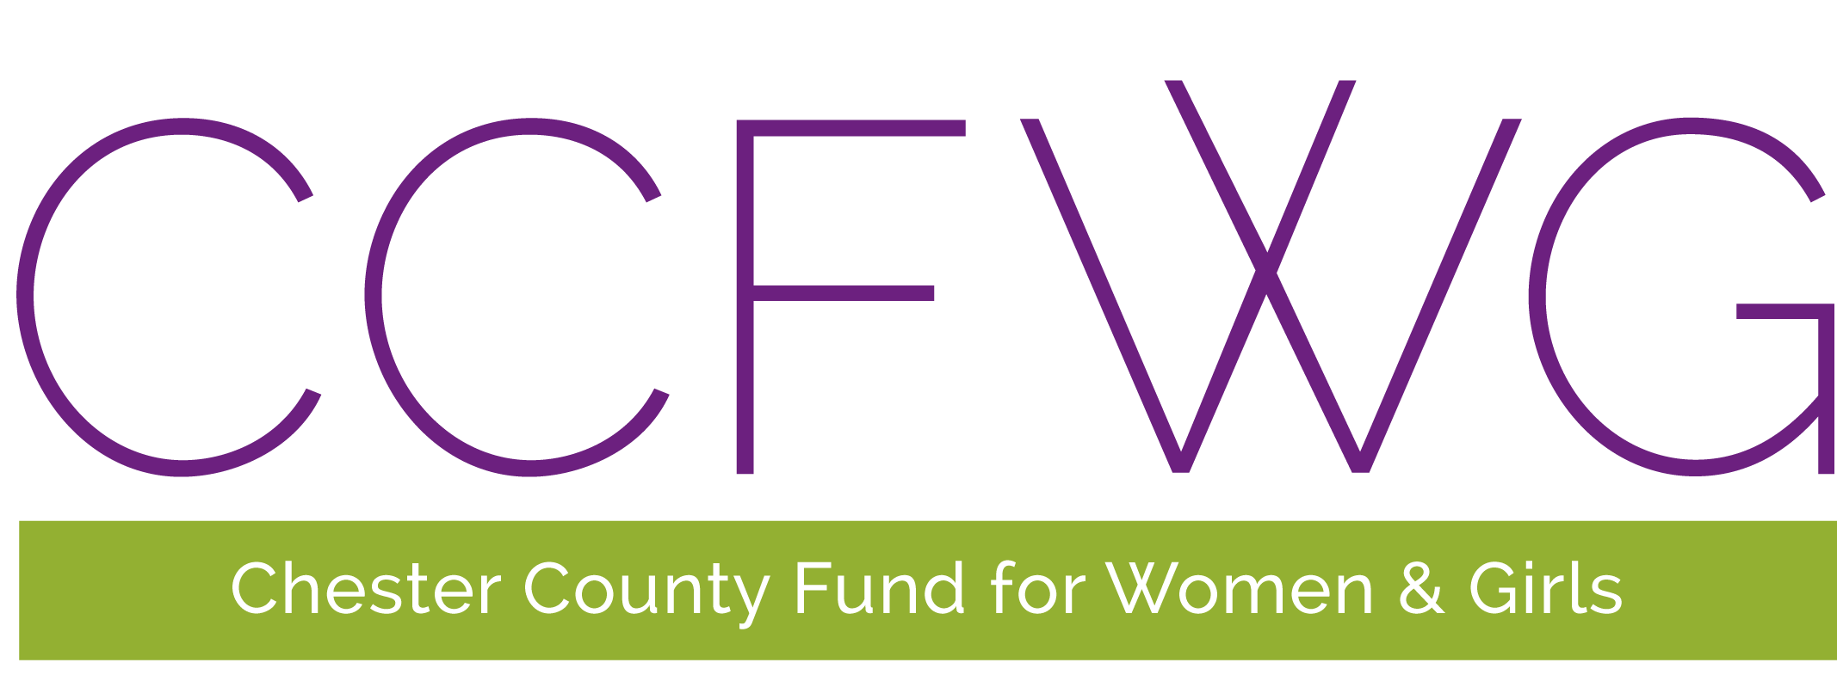

2018 Girls Advisory Board
Application Information and Form

Thank you for your interest in joining our 15th class of the Girls Advisory Board (GAB), CCFWG’s award-winning girls’ grantmaking program. Through GAB, we aim to educate a new generation of young women about the importance of philanthropy, community service and the positive difference each girl can make on the lives of others. Applicants must be entering 10th or 11th grade in the fall of 2018 and must live in Chester County. Selected participants may serve on GAB for up to two years.

Commitment and Attendance
Choosing to participate as a member of GAB is a significant decision. Members are actively involved in all aspects of the program, including:

- Discussing community needs and issues
- Learning about Chester County nonprofit organizations
- Developing funding priorities
- Creating a proposal
- Conducting site visits to nonprofit organizations
- Making funding decisions
Being a member of GAB requires a large time commitment and dedication. The objectives of each meeting rely on active participation because your voice is critical to the process. Thus, our attendance policy is strict. To participate in GAB, you must commit to attending all meetings. Please check your commitments to your family, academics, sports teams and extra-curricular activities to confirm your availability for the following dates:

GAB SCHEDULE 2018
Thursday, August 23 – 6:00-7:30 PM | Parent Orientation (parents only)
Saturday, September 8 – 9:00-12:30 PM | GAB Meeting
Saturday, September 29 – 9:00-12:30 PM | GAB Meeting
Saturday, October 13 – 9:00-2:00 PM | GAB Meeting
Saturday, October 20 – 9:00-12:30 PM | GAB Meeting
Saturday, November 10 – 9:00-12:30 PM | GAB Meeting
Saturday, November 17 – 9:00-2:00 PM | GAB Meeting
December 3-January 11 | Site Visits  *Each GAB girl attends approx. 2 site visits scheduled in the time frame based on their availability. Site visits are scheduled for after-school hours.
Saturday, December 15 | GAB Service Project
Saturday, January 12 – 9:00-12:30 PM | GAB Meeting
Saturday, February 2 – 9:00-2:00 PM | GAB Meeting
Tuesday, February 12 – 5:30-7:30 PM | GAB Wrap-Up Celebration

The following reasons may be considered an excused absence: an illness, observance of a religious holiday or school or family emergency. If one of these situations occur, a CCFWG representative must be notified prior to the meeting. Should an attendance issue or concern arise, the GAB member will be advised, and a decision about her further attendance will be discussed.

Please note that CCFWG makes every effort to avoid conflicting with test dates and religious holidays. Locations for meetings will vary and are typically hosted at the homes of CCFWG Board and committee members or at the CCFWG office.

Selection Process
Applicants will be selected based on their demonstrated commitment to full and active participation in GAB and their interest in CCFWG’s mission. The Selection Committee’s goal is to maximize the diversity of girls on GAB.
Application and Selection Process Timeline
Friday, May 25th GAB application deadline
May 28-June 1 A CCFWG representative will contact applicants via phone
June 4-17 In-person interviews at the CCFWG office for any eligible candidates who would
like to move forward in the selection process
Week of July 9th Notification to all GAB applicants
Thank you again for your interest in submitting an application to the GAB program. In order to apply, the following form must be filled out in its entirety. If you have any questions, please contact Maeve Kelly at 484-356-0940 or mkelly@ccfwg.org.

Applications can be sent via email or mail by the May 25th deadline to:

Maeve Kelly
Chester County Fund for Women and Girls
113 E. Evans Street, Suite A
West Chester, PA 19380
mkelly@ccfwg.org

2018 GAB Application Form
Please fill out the following information:
First Name:

Last Name:

Street Address:

City: State: Zip Code:

Home Phone:

Cell Phone:

E-Mail Address:

Best time to call you:

Best method to reach you (please circle):

Email Calling Cell Phone Text Calling Home Phone

Your age:

School you are presently attending: Current grade:

Grade in the fall of 2016:

Name of a parent(s) or guardian:

Contact information for parent(s) or guardian:

Cell Phone(s)

Work Phone(s)

E-Mail Address(es)

I would be interested in CCFWG’s assistance with transportation to and from GAB meetings, either through carpooling coordination or ride assistance. (Please circle)

Yes No

We are interested in learning more about you! CCFWG is committed to having a diverse group of young women participate in the Girls Advisory Board. The answers you give us on this application will be kept confidential.

- How did you hear about the Girls Advisory Board (GAB)? If you were referred, please tell us the name of the GAB member, teacher/advisor or adult friend who told you about GAB.

- Why are you interested in becoming a member of GAB?

- What are your hobbies and interests?

- What do you think are two important issues facing girls and young women in your community?
1.

2.

- What activities, if any, are you participating in at your school or in your community?

- What do you hope to experience as a member of GAB? What are your expectations for the program?

- Please write any additional information you would like to share with the selection committee (optional).

Please note the following statement and sign below:

I am very interested in participating in GAB 2018. I have checked the GAB calendar for any conflicts, and I fully understand the level of commitment required by the program.

NAME (typed or signed):
DATE:

